SQL TABLES- STRUCTURE AND DATA [CODE]

// *MATCHES TABLE*

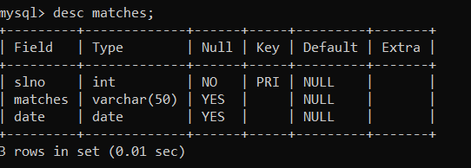

create table matches

-> (

-> slno int(5) not null primary key,

-> matches varchar(60),

-> date date

-> );

RECORDS/DATA:

Insert into matches values(1,"Chennai Super Kings vs Royal Challengers Bangalore","2022-03-23");

Insert into matches values(2,"Kolkata Knight Riders vs Sunrisers Hyderabad","2022-03-24");

Insert into matches values(3,"Mumbai Indians vs Delhi Capitals","2022-03-24");

Insert into matches values(4,"Rajasthan Royals vs Punjab Kings","2022-03-25");

Insert into matches values(5,"Delhi Capitals vs Chennai Super Kings","2022-03-26");

Insert into matches values(6,"Punjab Kings vs Kolkata Knight Riders","2022-03-27");

Insert into matches values(7,"Royal Challengers Bangalore vs Mumbai Indians","2022-03-28");

Insert into matches values(8,"Sunrisers Hyderabad vs Rajasthan Royals","2022-03-29");

Insert into matches values(9,"Punjab Kings vs Mumbai Indians","2022-03-30");

Insert into matches values(10,"Delhi Capitals vs Kolkata Knight Riders","2022-04-30");

Insert into matches values(11," Royal Challengers Bangalore vs Sunrisers Hyderabad","2022-03-31");

Insert into matches values(13," Punjab Kings vs Delhi Captitals","2022-04-01");

Insert into matches values(14," Royal Challengers Bangalore vs Rajasthan Royals","2022-04-02");

Insert into matches values(15,"Mumbai Indians vs Chennai Super Kings","2022-04-03");

Insert into matches values(16," Sunrisers Hyderabad vs Delhi Capitals","2022-03-04");

Insert into matches values(17," Royal Challengers Bangalore vs Kolkata Knight Riders","2022-04-05");

Insert into matches values(18," Chennai Super Kings vs Punjab Kings","2022-04-06");

Insert into matches values(19," Mumbai Indians vs Sunrisers Hyderabad","2022-04-06");

Insert into matches values(20," Royal Challengers Bangalore vs Delhi Capitals","2022-04-07");

Insert into matches values(21," Kolkata Knight Riders vs Rajasthan Royals","2022-04-07");

Insert into matches values(22,"Punjab Kings vs Sunrisers Hyderabad","2022-04-08");

Insert into matches values(23," Kolkata Knight Riders vs Chennai Super Kings","2022-04-09");

Insert into matches values(24," Mumbai Indians vs Punjab Kings","2022-04-10");

Insert into matches values(25," Chennai Super Kings vs Rajasthan Royals","2022-04-11");

Insert into matches values(26," Kolkata Knight Riders vs Delhi Capitals","2022-04-12");

Insert into matches values(27," Mumbai Indians vs Rajasthan Royals","2022-04-13");

Insert into matches values(28," Punjab Kings vs Royal Challengers Bangalore","2022-04-13");

Insert into matches values(29,"Chennai Super Kings vs Kolkata Knight Riders","2022-03-14");

Insert into matches values(30," Sunrisers Hyderabad vs Delhi Capitals","2022-04-14");

*// OWNER TABLE*

mysql> create table owner

-> (

-> ownerid varchar(10),

-> name varchar(30),

-> class varchar(2),

-> permissions varchar(5),

-> a_d varchar(2)

-> );

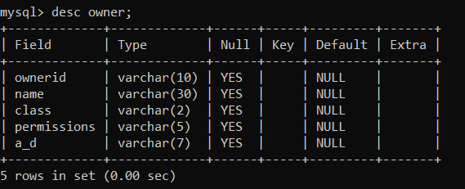

DATA:

Insert into owner values("XX1777R","Chirag","PO","rwx","AC/DC");

insert into owner values("XX18333R","Chiranjeevi","RO","rwx","a");

*// USERS TABLE-*

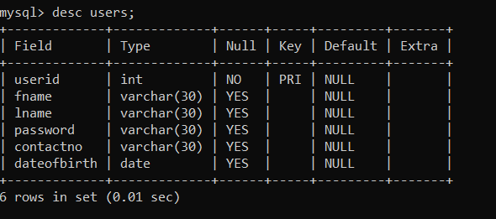

*// USER TABLE-*

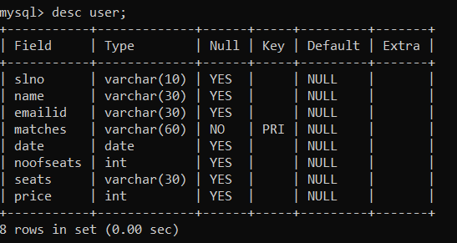

*// BANK TABLE-*

create table bank

-> (

-> bankid varchar(10) primary key,

-> bankname varchar(20),

-> paymentmode varchar(15)

-> );

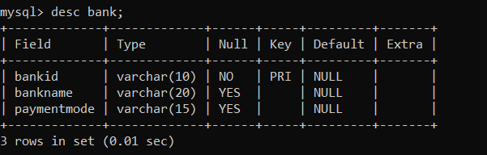

DATA FOR BANK TABLE-

Insert into bank values("1INDCCN777"," CANARA BANK","CREDIT CARD");

Insert into bank values("1INDICICI3"," ICICI BANK","CREDIT CARD");

Insert into bank values("1INDSBI743"," STATE BANK OF INDIA","CREDIT CARD");

Insert into bank values("1INDCB11AA"," CITI BANK","CREDIT CARD");

Insert into bank values("1INDHDFC30"," HDFC BANK","CREDIT CARD");

Insert into bank values("1INDIDFCDB"," IDFC BANK","DEBIT CARD");

Insert into bank values("1INDAX88DB"," AXIS BANK","DEBIT CARD");